|  |  |  |  |  |  |
| --- | --- | --- | --- | --- | --- |
| Date | 28-Nov-22 | | | Tester Name | Shahabuddin Syed |
| Environment | Penfax - Test | | | Login used |  |
| Operating System | Windows | Version: | Update: | | |
| Software Used | Edge | Version: | Update: | | |
| Select Software | Version: | Update: | | |
| Release version | 22.4.1 | | | | |
| Title | SRB | | | | |
| Test Type | Regression | | | | |
| Test Scenario | Process a spousal breakdown payment to remain in VPB for a member is in VPB currently | | | | |
|  |  | | | | |
| Expected Results |  | | | | |
| Pass/Fail | Pass | | | JIRA# | N/A |

Describe your steps with screenshots:

Search for the member

Click on their stakeholder ID

Precondition:

Member must be in Active or deferred status with PEPP and must have a spouse.

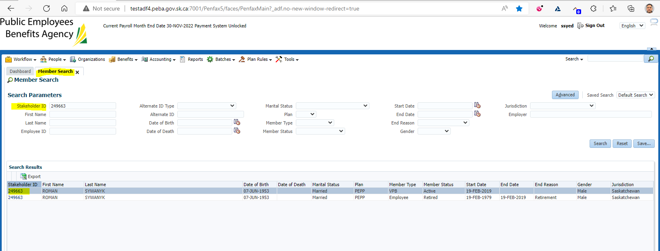

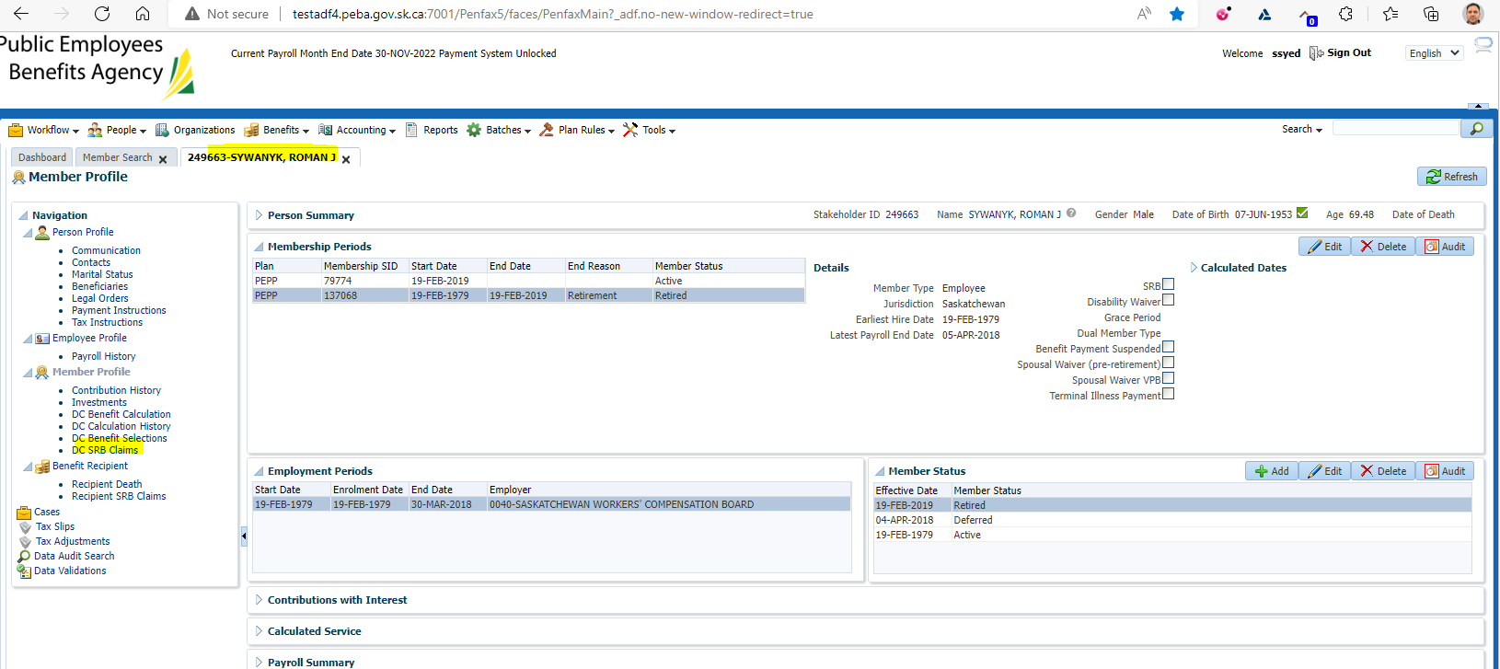

Click on DC SRB Claims

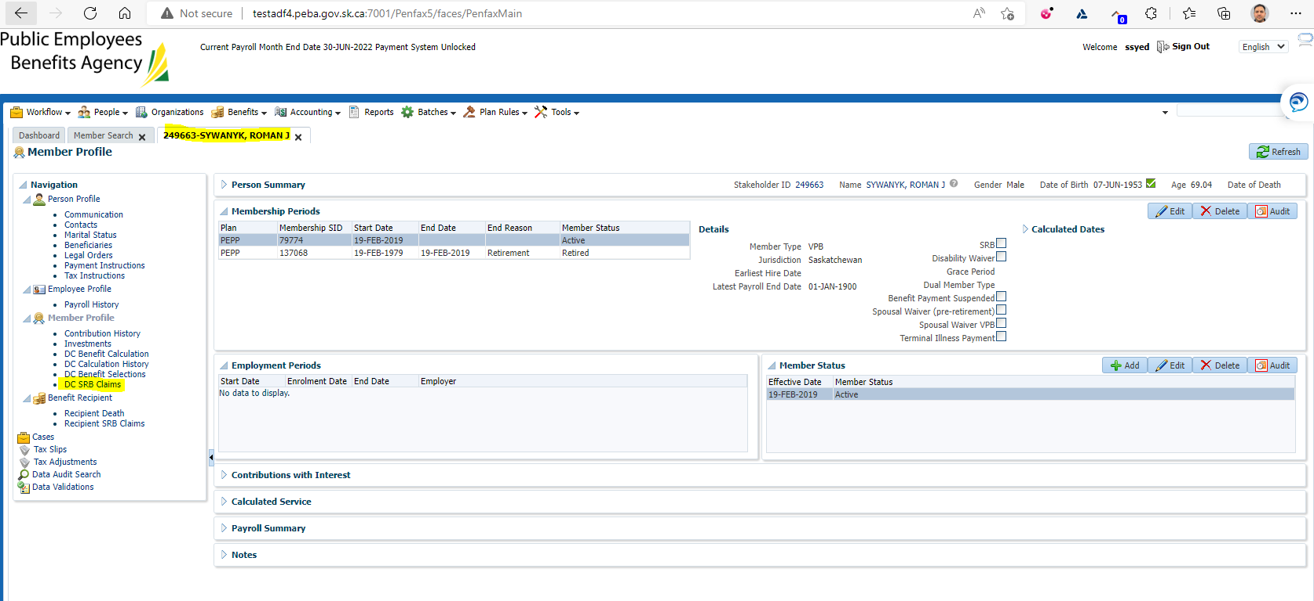

Click on Add under DC SRB Claims

This will open up a new ADD DC SRC Claim Tab

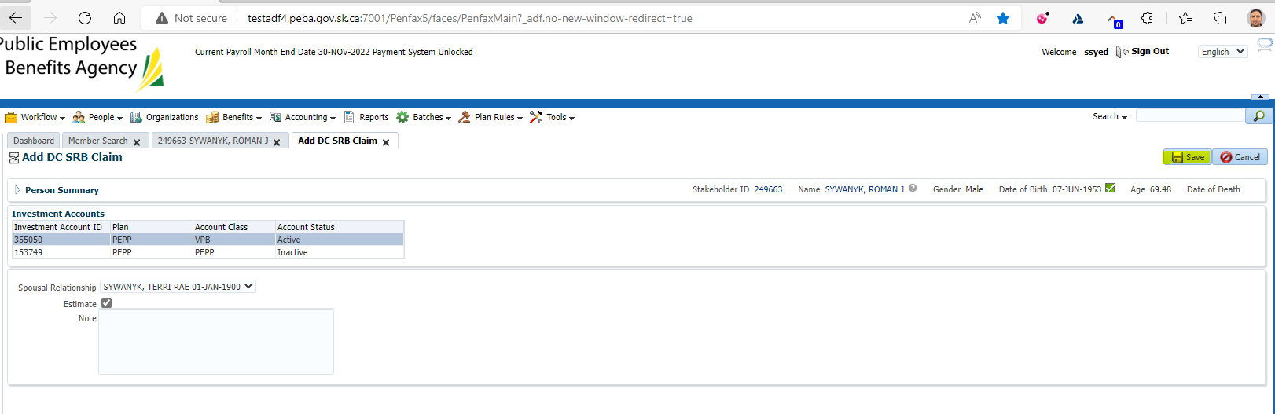

Click on Save button

This will open a new screen with a DC SRB Claim ID

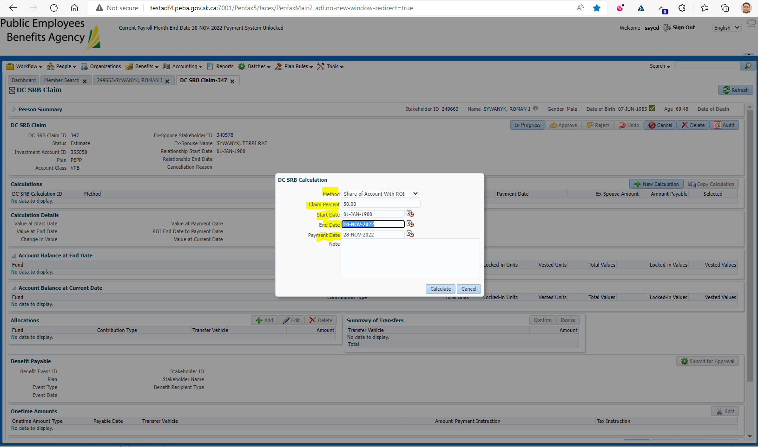

Need to enter the Method and the End Date

Under Method Select Share of Account with ROI

End Date select as current date

Under the Calculations you will see an Ex-spouse amount

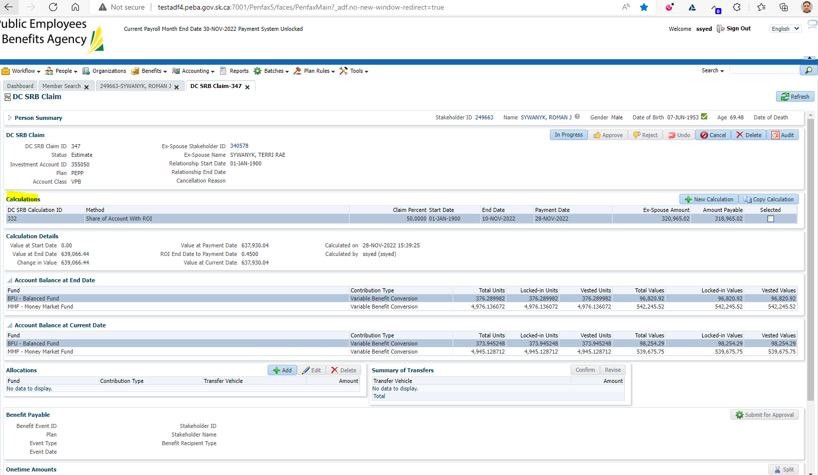

Under Allocations Click Add  
Under Transfer vehicle select Variable Pension Benefit Account  
Under amount input the Ex-Spouse Amount  
Click Save  
Under Summary of Allocations click Confirm

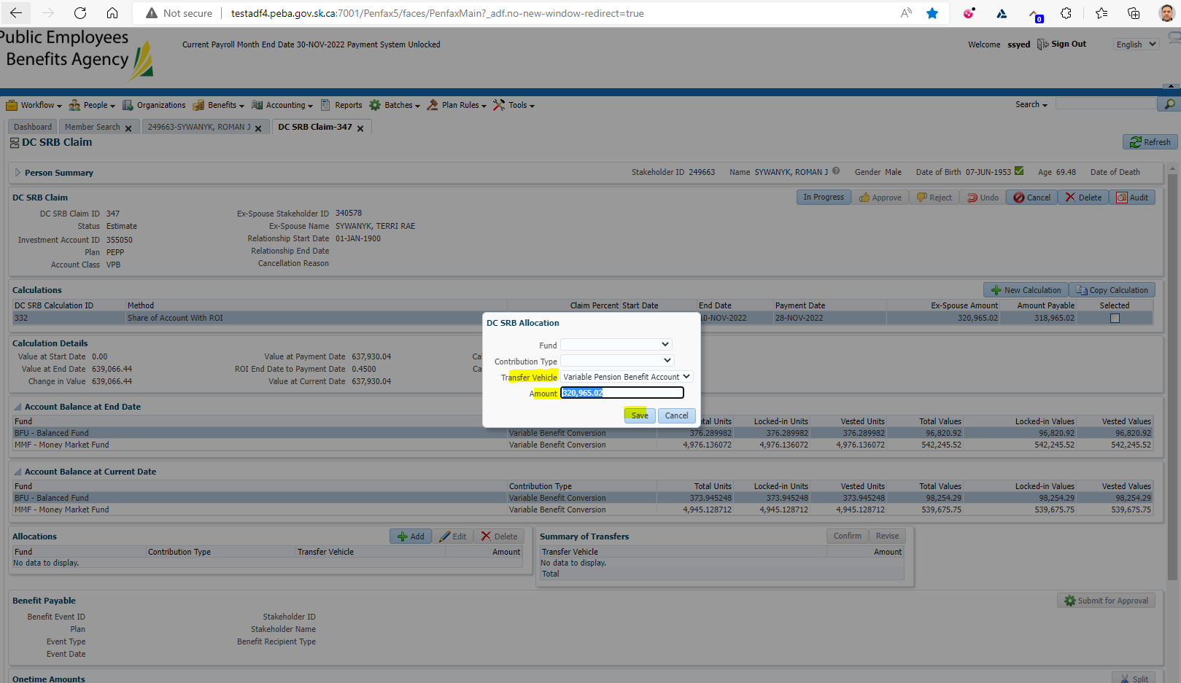

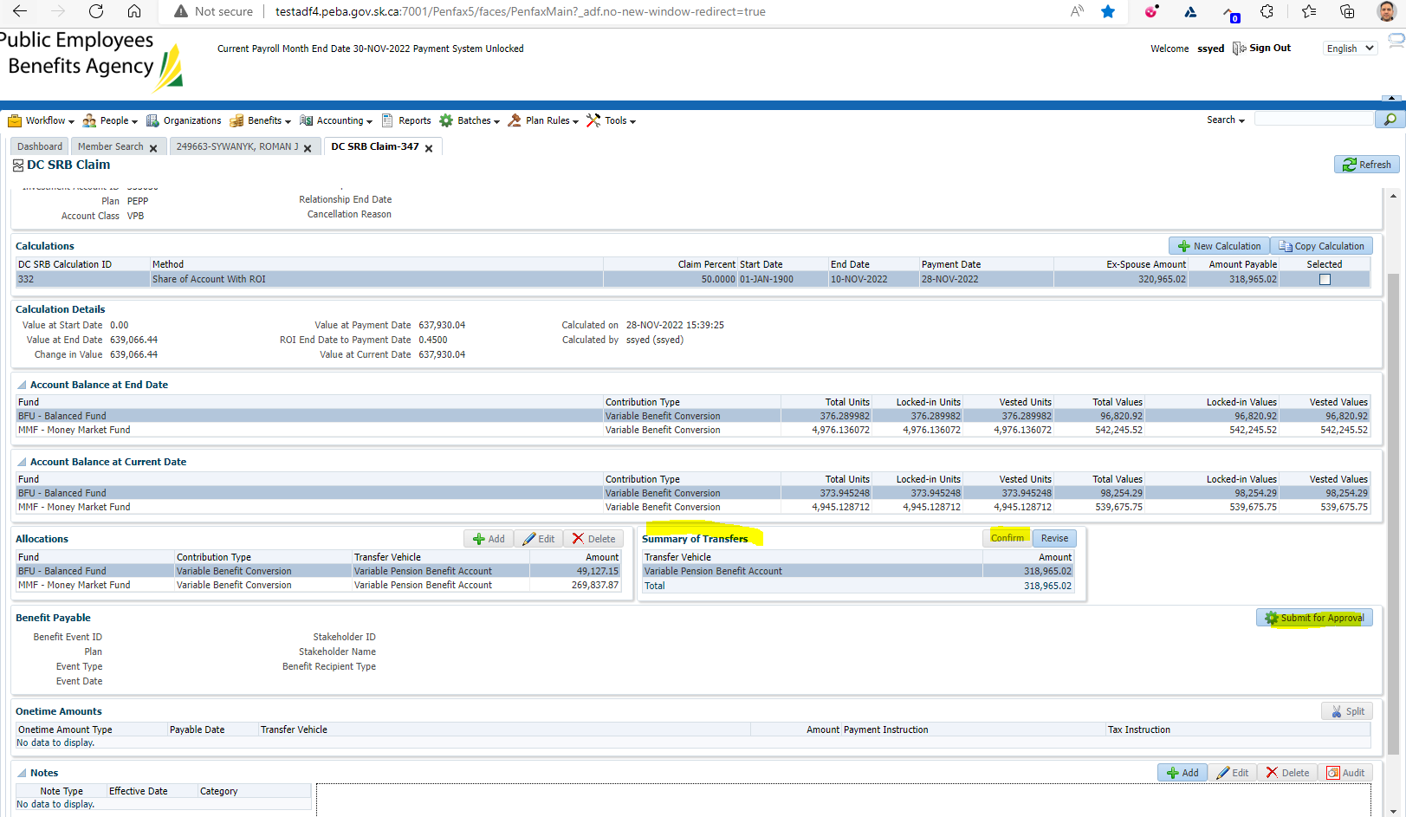

At the top of the screen under DC SRB Claim put In Progress  
Click Submit for Approval  
Approve the file



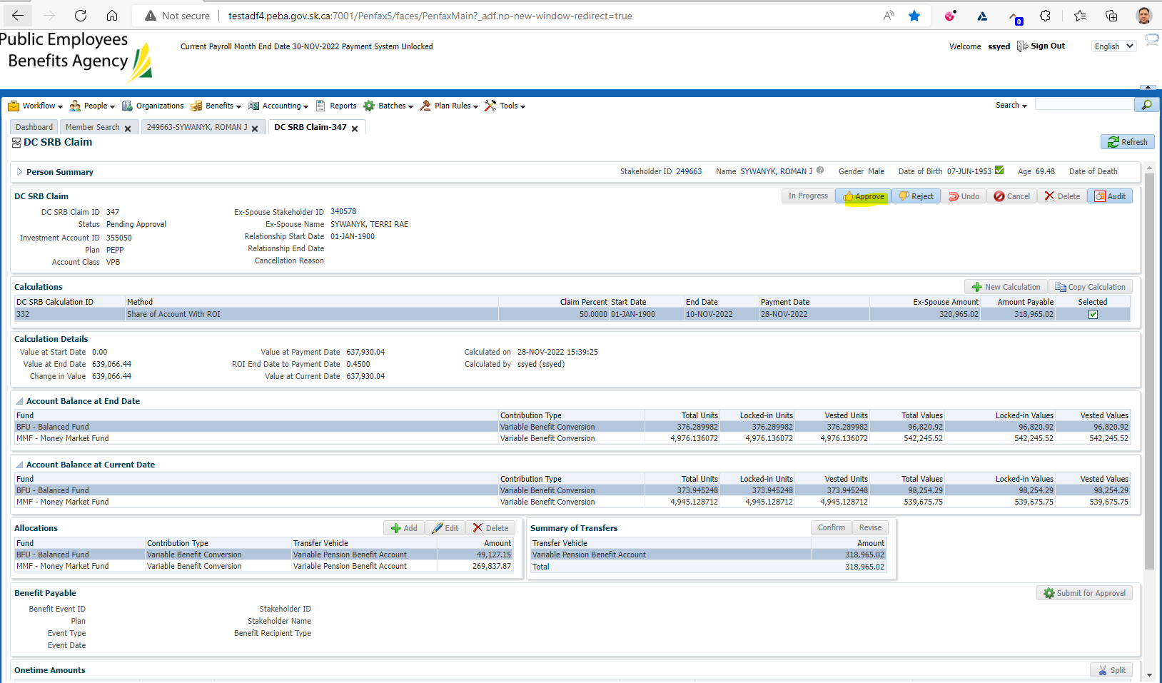

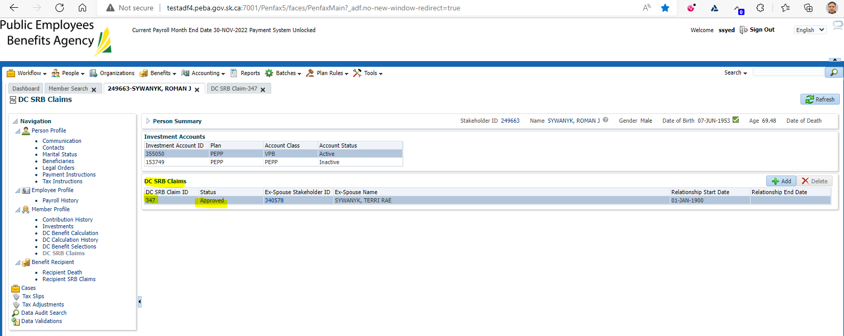

Wait for the overnight batches to run

**Note: Letter will not be generated if the money is transferred to an inside transfer vehicle, like a PEPP or VPB

**Note: Letter will be generated only if the money is transferred to an outside transfer vehicle, like a LIRA or RRSP

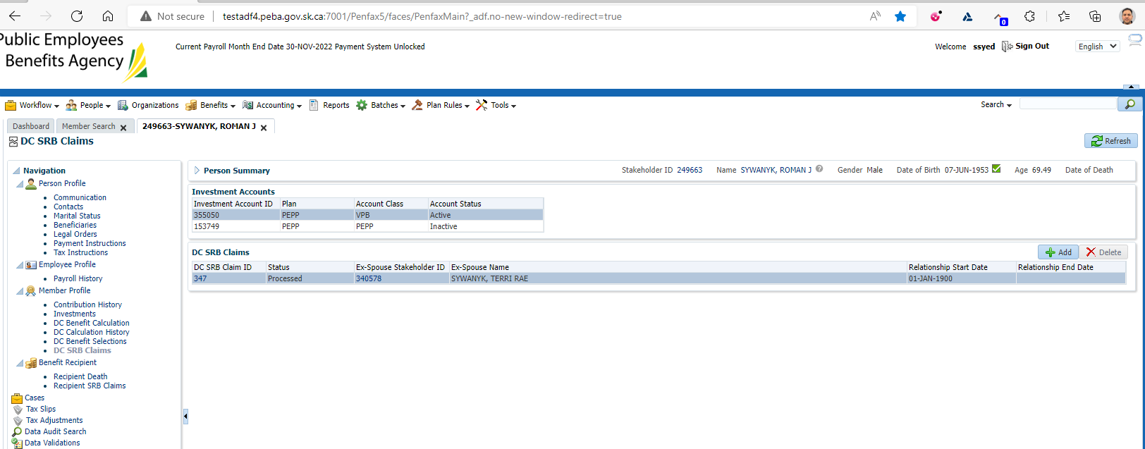

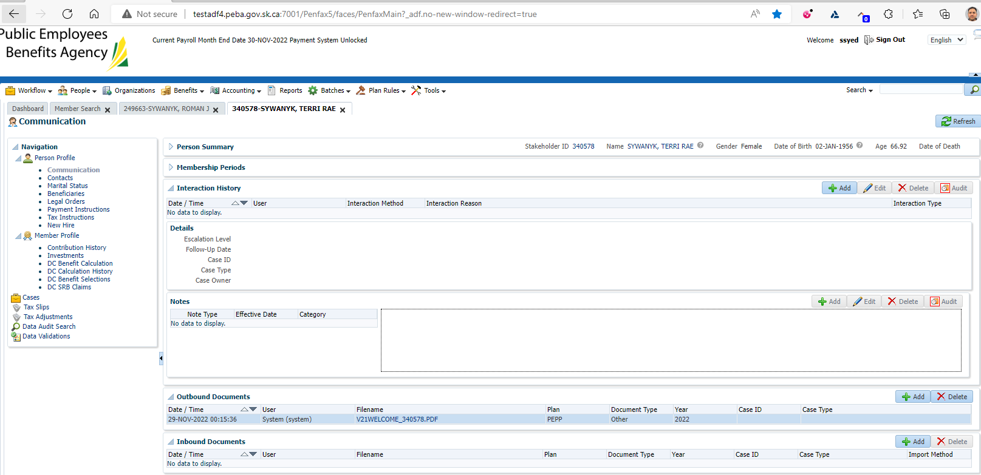

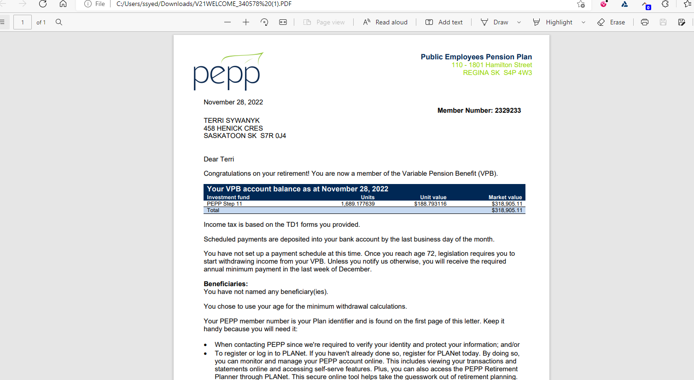

SID: 237526

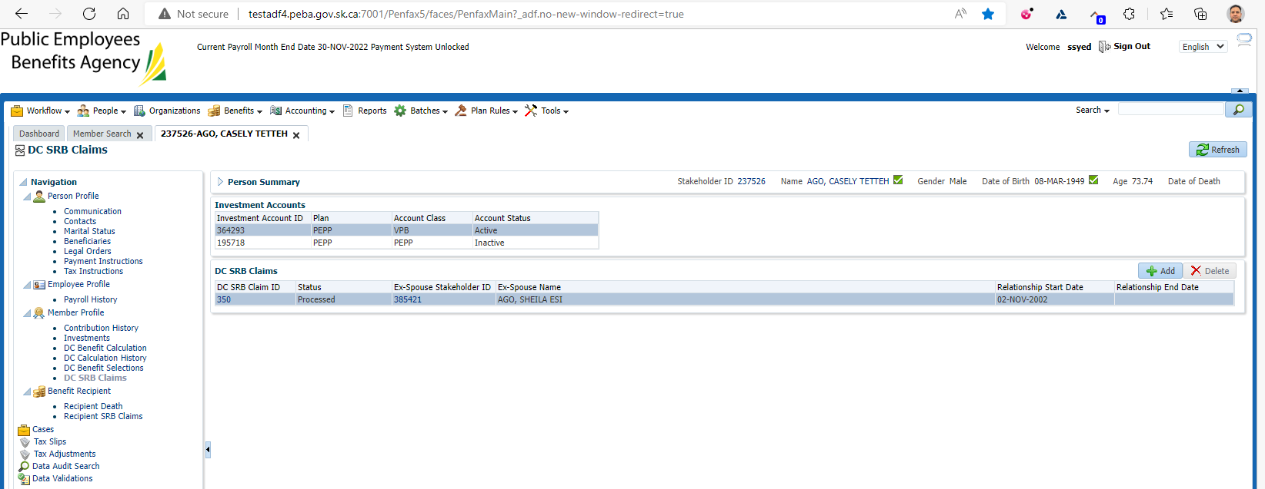

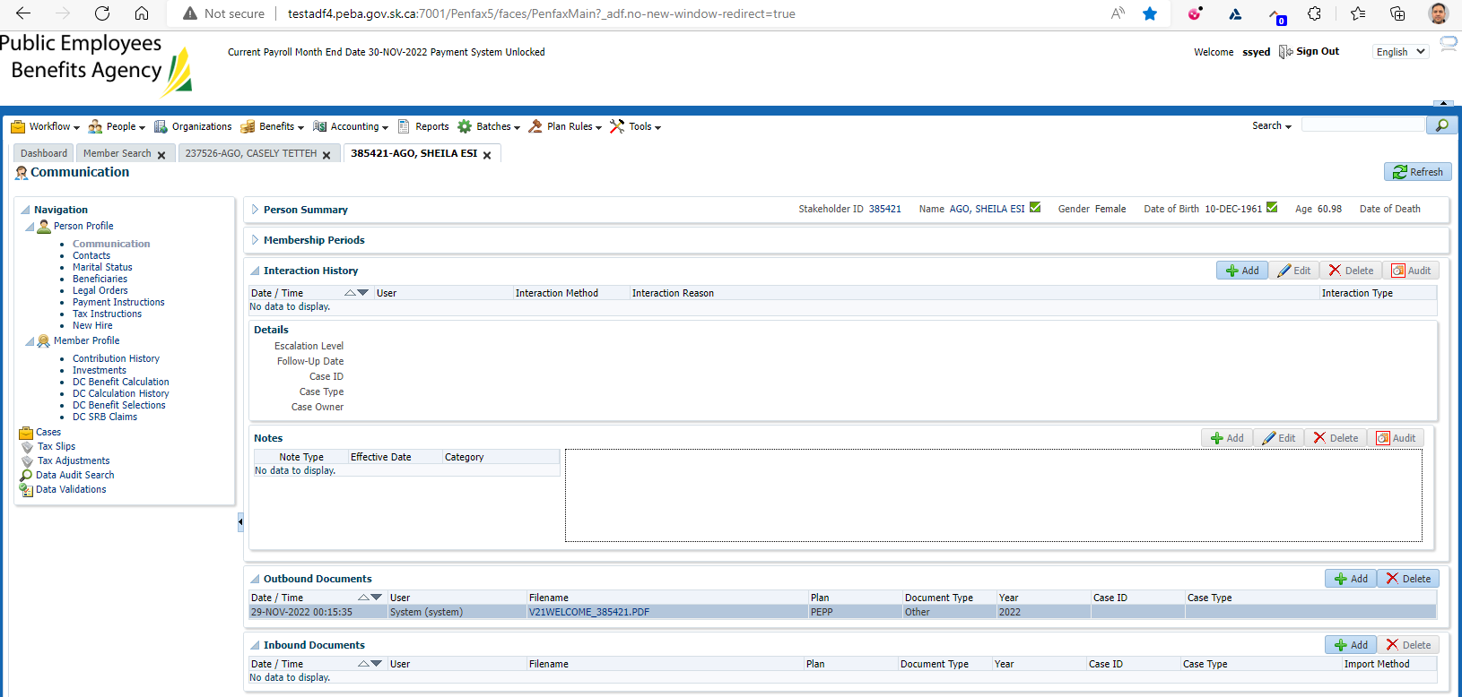

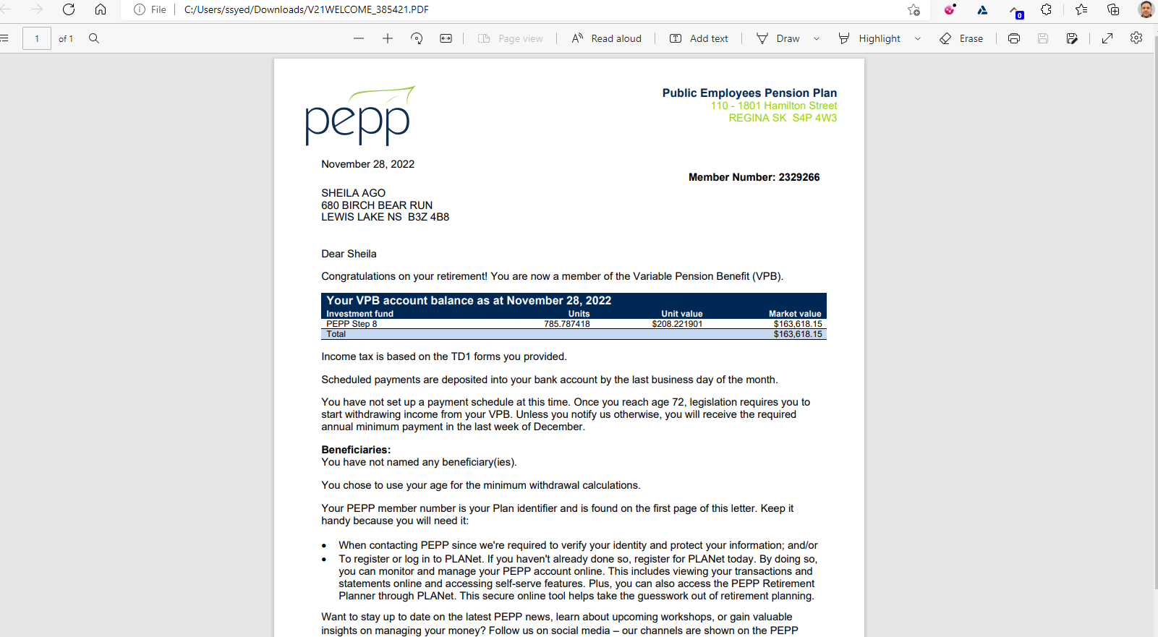

Letter will not be generated if the money is transferred to an inside transfer vehicle, like a PEPP or VPB